# extend the calendar to also include dividends for watchlist stocks That's a small backend change to events.py — fetch both earnings and dividends from yfinance and return them together with a "Dividends" label.

# DTE corresponding to the holding period does not appear.
- The range of DTE should be displayed at the 1st position in the logs

# tab direction+ Horizon
** In the Add these Parameters to the tab direction+ Horizon add a section for option on the right. Then put these parameters with default values but that I can overwrite
Parameter | Hard-reject threshold
Volume | < 10
Open interest | < 50
Bid-ask spread | > 15% of mid price
Delta | < 0.20 or > 0.80
DTE | < 7 days or > 90 days

** Right now the trend is only determined by EMA and is almost failing for All
Do the following Changes
Give a button to choose between SMA and EMA
The Default values remain
EMAs/SMAs 20/50 50/200 50/200 For intraday swing and position respectively
Give the possibility to choose different slow and fast

I flagged AMZN and BKR
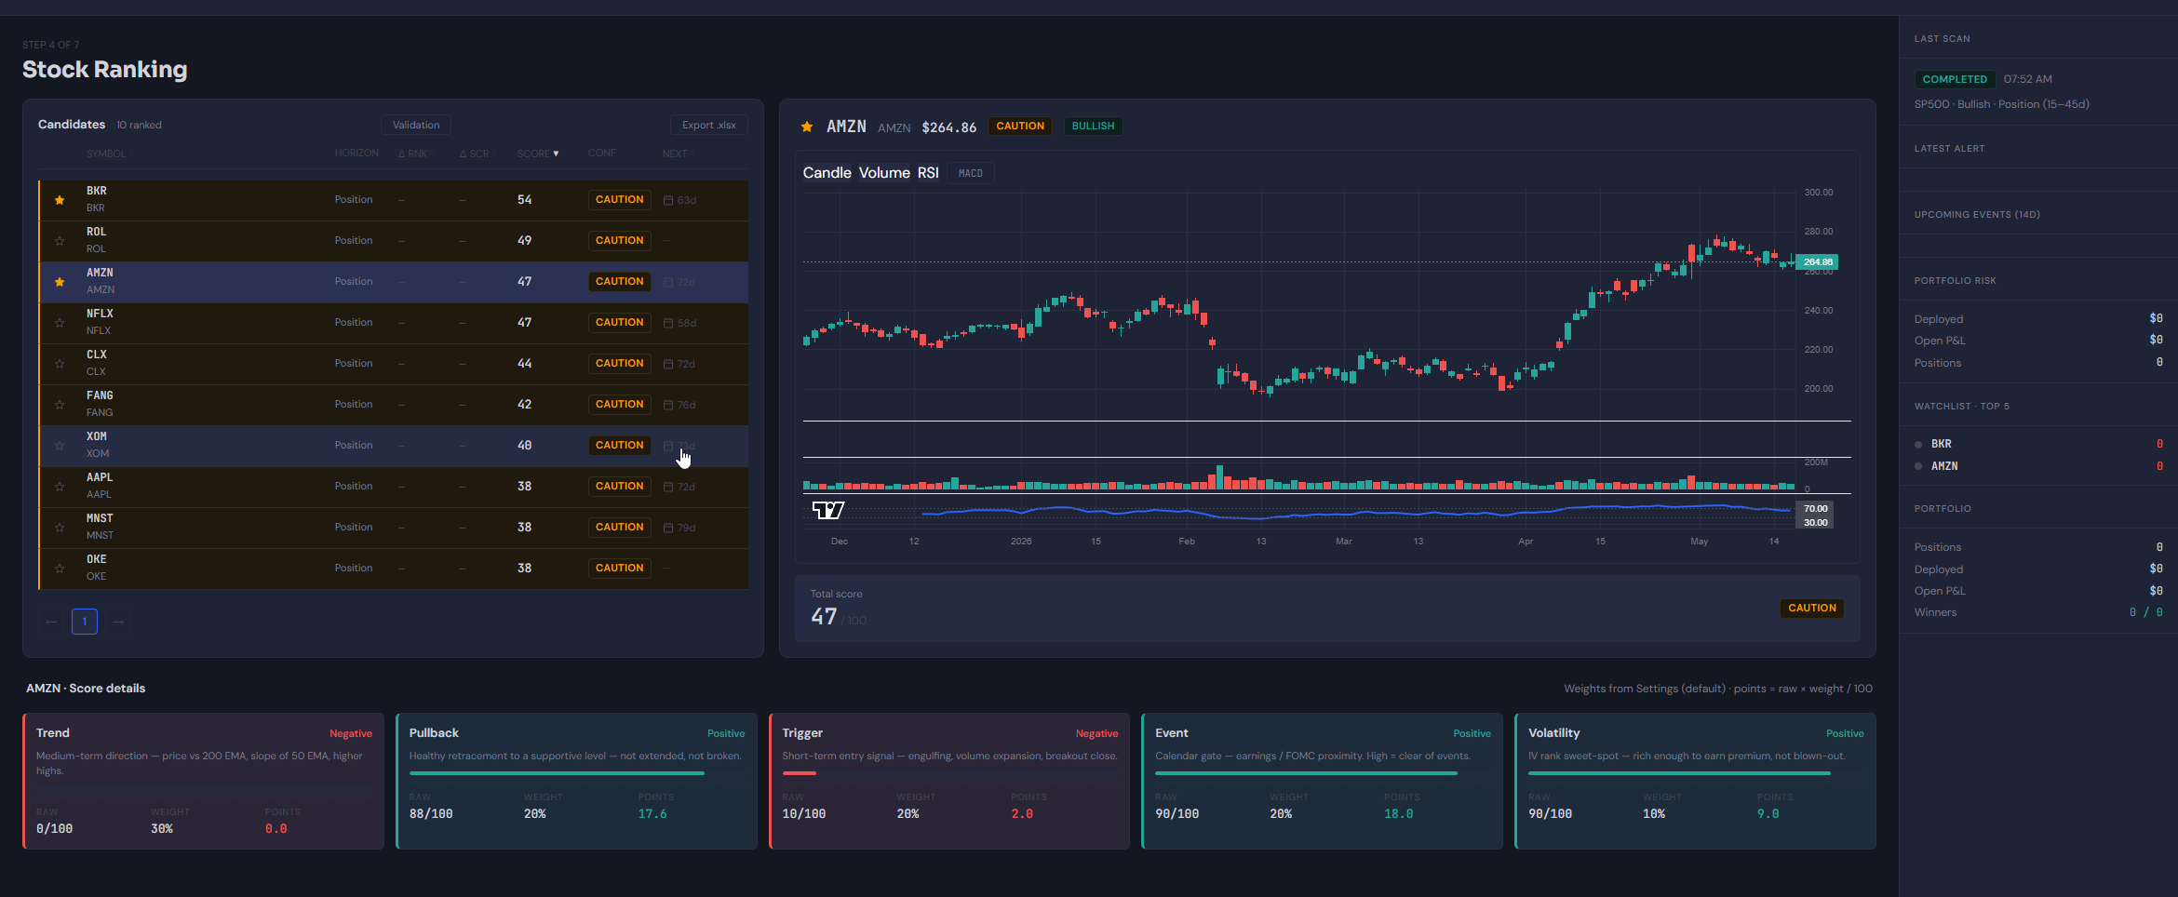

# Submitted orders do not appear in portfolio

